Task No & Title: | BSBCMN211A Participate in workplace safety procedures
Title: | Ergonomics Explained worksheet
Suitable for Classes: | Certificate II Business Cert II in ICT
Area: | Technology & Enterprise
Teacher: | Mr Peter Faulks
Timeline | 1 Lesson
Date Due: | Today

Task Brief:
Files Required | Camera

Items highlighted in yellow are tasks for you to complete
Items in Blue are help tips

ERG100 Ergonomics Explained Worksheet
1. Find information on Ergonomics from one of these sites explain what is Ergonomics in your own words:

Ergonomics

Ergonomics is the application of scientific information concerning humans to the design of objects, systems and environment for human use.

http://www.ergonomics.com.au/

Your answer: Ergonomics is…

Use the Internet to browse some of the following sites.
ERGONOMICS is essentially about "fitting work to people". It's the process of designing or arranging workplaces, products and systems so that they fit the people who use them.

Prolonged or improper computer abuse can lead to injuries or disorders of the hands, wrists, elbows, eyes, neck, and back. Two behavioral health risks are computer addiction and technology overload. Computer addiction occurs when someone becomes obsessed with using a computer. Individuals suffering from technology overload feel distressed when deprived of computers and mobile devices. Once recognized, both computer addiction and technology overload are treatable disorders. Computer manufacturing processes and computer waste are depleting natural resources and polluting the environment. When computers are discarded in landfills, they release toxic materials and potentially dangerous levels of lead, mercury, and flame retardants.

2. Use a camera and take photographs of your classroom or work environment. Photograph chairs, computers, and matters that might appear to contravene ergonomic principles of safety

Ergonomics is the study of work and healthy work practices. The goal of ergonomics is to make work more comfortable and to improve both health and productivity for the employee and also the clients.
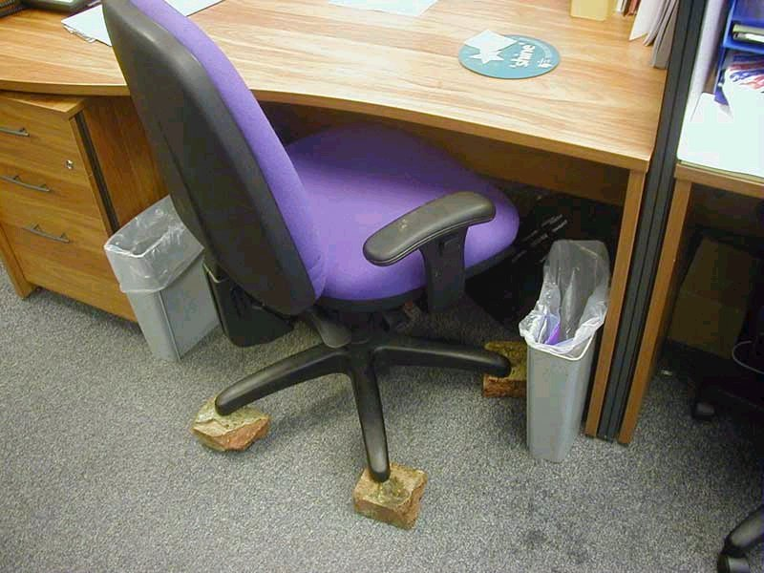
Ergonomics, however, deals with more than the physical aspects of work. A more detailed and all encompassing approach to ergonomics addresses three areas of work – the physical, environmental and emotional areas. For example:

Physical
Ensuring that you are seated correctly at your computer workstation can make you more comfortable, as well making you more productive.

Environmental
Eliminating glare on your monitor screen makes it more comfortable and easier to read information displayed on the screen.

Emotional
Organising your time properly ensures that deadlines will be able to be met, reducing the amount of stress.
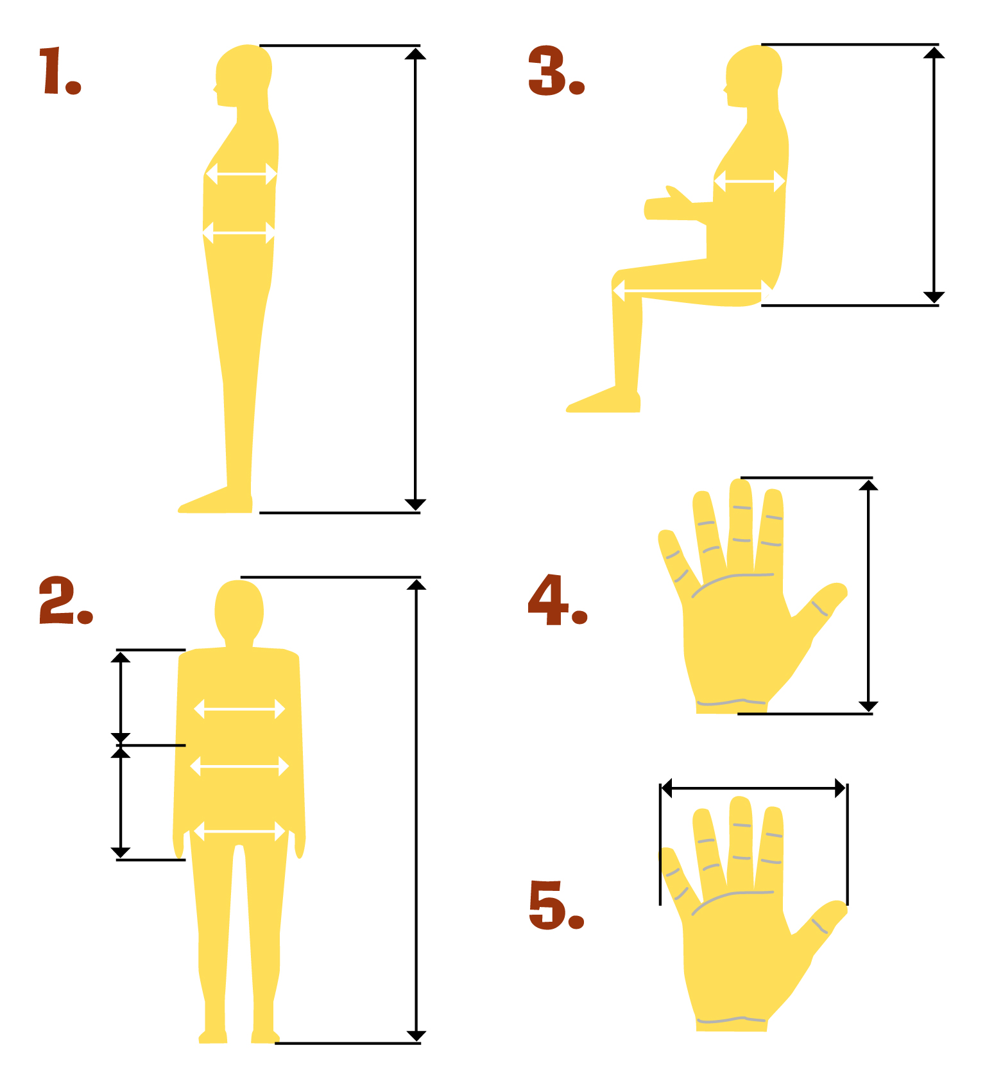

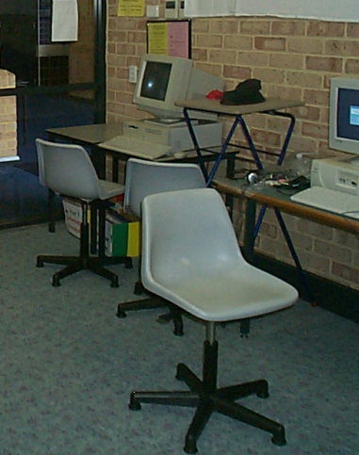

Given the information in this document…

3. Take a photograph in the computer room of any hazards that you feel may be a danger to users

4. Take two photographs

One showing how NOT to sit at a computer and

one how TO sit properly at a computer

Explain the ergonomic principles involve in both
Classroom Chair

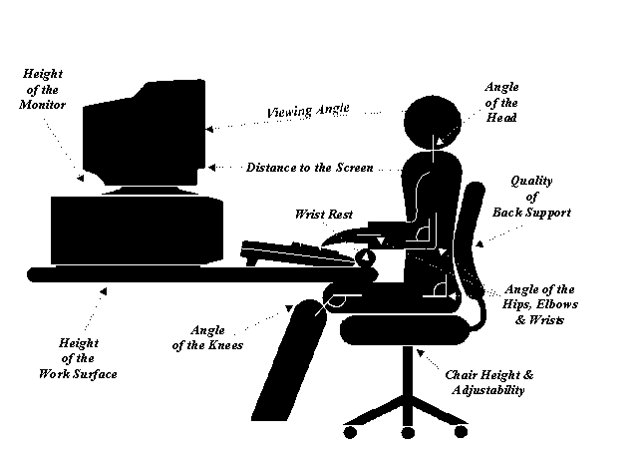
Ergonomics terminology
Anthropometry: body sizes, shapes; populations and variations
Biomechanics: muscles, levers, forces, strength
Environmental physics: noise, light, heat, cold, radiation, vibration
Body systems: hearing, vision, sensations
Applied psychology: skill, learning, errors, differences
Social psychology: groups, communication, learning, behaviours.

Ergonomists need a mature and sensitive ability to listen, and to consult carefully with the people who may have to use the system or product being developed or changed. They work at the different interfaces where the user contacts the product or system - physically, mentally, or otherwise. The aim of ergonomics is to develop a comfortable, safe (and thus, a productive) work system, by bringing human factors thinking and data into the plan. This means including consideration of specific human abilities (and limits) in the design process. These can mean body size, strength, skill, speed, sensory abilities (vision, hearing, etc), even attitudes.

How to sit at a computer: useful advice from Mark Dohrmann and Partners
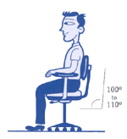
STEP 1: Your Chair

* Push your hips as far back as they can go in the chair.
* Adjust the seat height so your feet are flat on the floor and your knees equal to, or slightly lower than, your hips.
* Adjust the back of the chair to a 100°-110° reclined angle. Make sure your upper and lower back are supported. Use inflatable cushions or small pillows if necessary. If you have an active back mechanism on your chair, use it to make frequent position changes.
* Adjust the armrests (if fitted) so that your shoulders are relaxed. If your armrests are in the way, remove them.

STEP 2: Your Keyboard
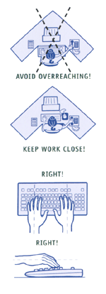

An articulating keyboard tray can provide optimal positioning of input devices. However, it should accommodate the mouse, enable leg clearance, and have an adjustable height and tilt mechanism. The tray should not push you too far away from other work materials, such as your telephone.

* Pull up close to your keyboard.
* Position the keyboard directly in front of your body.
* Determine what section of the keyboard you use most frequently, and readjust the keyboard so that section is centred with your body.
* Adjust the keyboard height so that your shoulders are relaxed, your elbows are in a slightly open position (100° to 110°), and your wrists and hands are straight.
* The tilt of your keyboard is dependent upon your sitting position. Use the keyboard tray mechanism, or keyboard feet, to adjust the tilt. If you sit in a forward or upright position, try tilting your keyboard away from you at a negative angle. If you are reclined, a slight positive tilt will help maintain a straight wrist position.
* Wristrests can help to maintain neutral postures and pad hard surfaces. However, the wristrest should only be used to rest the palms of the hands between keystrokes. Resting on the wristrest while typing is not recommended. Avoid using excessively wide wristrests, or wristrests that are higher than the space bar of your keyboard.
* Place the pointer as close as possible to the keyboard. Placing it on a slightly inclined surface, or using it on a mousebridge placed over the 10-keypad, can help to bring it closer.

If you do not have a fully adjustable keyboard tray, you may need to adjust your workstation height, the height of your chair, or use a seat cushion to get in a comfortable position. Remember to use a footrest if your feet dangle.

STEP 3: Monitor, Document, and Telephone
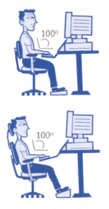
Incorrect positioning of the screen and source documents can result in awkward postures. Adjust the monitor and source documents so that your neck is in a neutral, relaxed position.

* Centre the monitor directly in front of you, above your keyboard.
* Position the top of the monitor approximately 2-3” above seated eye level. (If you wear bifocals, lower the monitor to a comfortable reading level.)
* Sit at least an arm's length away from the screen and then adjust the distance for your vision.
* Reduce glare by careful positioning of the screen.

* Place screen at right angles to windows

* Adjust curtains or blinds as needed
* Adjust the vertical screen angle and screen controls to minimize glare from overhead lights
* Other techniques to reduce glare include use of optical glass glare filters, light filters, or secondary task lights

* Position source documents directly in front of you, between the monitor and the keyboard, using an in-line copy stand. If there is insufficient space, place source documents on a document holder positioned adjacent to the monitor.
* Place your telephone within easy reach. Telephone stands or arms can help.
* Use headsets and speaker phone to eliminate cradling the handset.

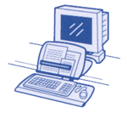
STEP 4: Pauses and Breaks

Once you have correctly set up your computer workstation use good work habits. No matter how perfect the environment, prolonged, static postures will inhibit blood circulation and take a toll on your body.

* Take short 1-2 minute stretch breaks every 20-30 minutes. After each hour of work, take a break or change tasks for at least 5-10 minutes. Always try to get away from your computer during lunch breaks.
* Avoid eye fatigue by resting and refocusing your eyes periodically. Look away from the monitor and focus on something in the distance.
* Rest your eyes by covering them with your palms for 10-15 seconds.
* Use correct posture when working. Keep moving as much as possible.

References

Welcome to the Office Ergonomics Self-help Site
http://www.3m.com/cws/selfhelp/index.html

ELECTRICAL & MECHANICAL SAFETY INFORMATION www.hp.com.ergo

Healthy Computing Office Ergonomics
http://www.healthycomputing.com/office/setup/

The University of Sydney Office Ergonomics Guidelines
http://www.usyd.edu.au/risk/ohsmanual/ergonomics/ergoguide.shtml

Department of Consumer and Employment Protection WorkSafe Smart Move
http://www.safetyline.wa.gov.au/pagebin/edcnwssm0018.htm

HP online safety guide ……
http://www.hp.com/ergo/productsafetypolicy_gp.html

Save the work

Student Name: | Date submitted:
I declare this evidence to have been produced by me the undersigned.

Candidate’s signature:
Title of Portfolio evidence presented (include Unit No and section i.e. 03.05)
:-
□ Outcomes from learning programs (including self-learning and online learning)
□ Assessment feedback (from a trainer or assessor)
□ Observation checklists (from a workplace supervisor or assessor)
□ Written statements or references (including workplace supervisors, community leaders)
□ Job descriptions
□ Work journal
□ Work samples
□ Finished products
□ Product descriptions or specifications (supporting the product samples included)
□ Statutory declarations
□ List others (or delete any from above not provided)
- All work submitted to be word processed and spell checked.
- There must be at least two samples of evidence for each
Element within the Unit of Competency. This is sample 1 / 2
- All work submitted must be of a high quality and meet the
requirements of the Unit of Competency.
Other evidence (List each piece):
Assessor to complete
Evidence is Valid Sufficient Authentic Current
□ □ □ □

Assessor signature: _________________________________Date: _____________
Peter Faulks, BA Soc Sci, Grad Dip Ed, Cert IV AWT
Certificate II in Business assessor/teacher
Assessor to complete

Student is declared Competent Not Yet Competent
□ □

Keep a copy of this report with your file for evidence

